[0001] TITLE OF INVENTION
OCTOPAS (Oil spill Cleanup Through an Optimized Pragmatic Automated System) - Automated System and Method for Oil Spill Cleanup with Sorbent Deployment and On-Site Recycling
[0002] INVENTOR:
Monish Saravana Kumar Divya Sundari

[0003] BACKGROUND OF THE INVENTION
This invention relates generally to environmental remediation technologies, and more specifically to systems and methods for cleaning up oil spills in aquatic environments.
Oil spills in oceans, lakes, and other waterways pose a significant threat to marine ecosystems, coastal economies, and public health. Current conventional methods for oil spill cleanup often rely on the manual or semi-automated deployment of single-use sorbent materials. These methods suffer from several drawbacks:
a) Low Efficiency: Typically, only a small percentage (e.g., around 30%) of the spilled oil is recovered.
b) Waste Generation: Single-use sorbents, once saturated with oil, become hazardous waste themselves, requiring costly and environmentally burdensome disposal. This leads to significant waste accumulation and resource depletion for sorbent production.
c) High Cost: The combination of sorbent material costs, deployment efforts, and disposal of contaminated sorbents results in very high cleanup expenses per tonne of oil spilled.
d) Slow Response & Deployment Inefficiency: The effectiveness of sorbent deployment is often a limiting factor, even with highly efficient sorbent materials. Manual or unoptimized deployment strategies can lead to incomplete coverage of the spill or inefficient use of sorbents.
e) Environmental and Economic Damage: Unrecovered oil causes long-lasting damage to flora, fauna, and local industries such as fishing and tourism.
There is a clear and unmet need for a more efficient, cost-effective, sustainable, and automated system for oil spill cleanup that not only improves oil recovery rates but also minimizes waste by enabling the recycling and reuse of sorbent materials directly at or near the spill site.
[0004] SUMMARY OF INVENTION
The present invention, referred to as OCTOPAS (Oil spill Cleanup Through an Optimized Pragmatic Automated System), provides an automated system and method for oil spill cleanup. It integrates intelligent image processing, autonomous robotic deployment and retrieval of sorbents, and an on-board system for recycling and reusing said sorbents, along with recovery of the absorbed oil.
The OCTOPAS system comprises of :
a) An Image Acquisition and Processing Sub-System: Typically utilizing images captured by an unmanned aerial vehicle (e.g., a drone) or other remote sensing means. This sub-system includes a software application (OCTOPAS App) with a novel image processing algorithm to detect and analyze the oil spill. The algorithm identifies oil slicks, distinguishes them from water, calculates parameters such as spill area and optimal cleanup paths, and may estimate the volume or thickness of the oil.
b) An Autonomous Sorbent Deployment and Retrieval Unit: Typically an unmanned surface vehicle (OCTOPAS Boat) equipped with mechanisms for storing, controllably deploying, and subsequently retrieving sorbent materials. The boat navigates autonomously based on instructions received from the Image Processing Sub-System.
c) An On-Board Sorbent Recycling Sub-System: Integrated within the OCTOPAS Boat, this sub-system is designed to receive oil-laden sorbents, separate the absorbed oil from the sorbent material, and prepare the sorbent for immediate redeployment. The recovered oil is collected for proper disposal or potential repurposing.
d) Reusable Sorbent Material: While the system can be adapted for various sorbents, it is preferably used with highly efficient and reusable sorbents, such as flexible hydrophobic silica aerogels (e.g., MTMS-based aerogel), which exhibit high oil absorption capacity and can withstand multiple absorption-desorption cycles.
The method of operation involves:
- Capturing images of the oil spill.
- Processing these images using the OCTOPAS App to identify oil patches and determine an optimized deployment strategy and path for the OCTOPAS Boat(s).
- Transmitting this path and deployment instructions to the OCTOPAS Boat.
- The OCTOPAS Boat autonomously navigating to the designated areas and deploying the sorbent material onto the oil slicks.
- After a sufficient absorption period, the OCTOPAS Boat retrieving the oil-saturated sorbents.
- Feeding the retrieved sorbents into the on-board Sorbent Recycling Sub-System, where oil is extracted from the sorbent.
7. The cleaned, recycled sorbent being made available for immediate redeployment by the OCTOPAS Boat.
8. The recovered oil being stored for later offloading.
The OCTOPAS system aims to significantly improve oil spill cleanup efficiency (e.g., potentially recovering over 70-90% of spilled oil), drastically reducing the amount of waste generated by enabling sorbent reuse for multiple cycles (e.g., 10 or more cycles), and lowering the overall cost of cleanup operations. Its automated nature allows for rapid response and continuous operation.
[0005] DRAWINGS / VISUALS
Figure 1. Workflow diagram of how OCTOPAS System operates from end to end. 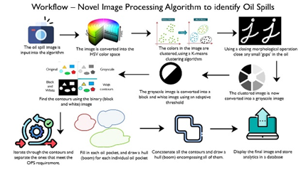
Figure 2. Workflow diagram of how OCTOPAS App identifies oil spills from a standard drone image.
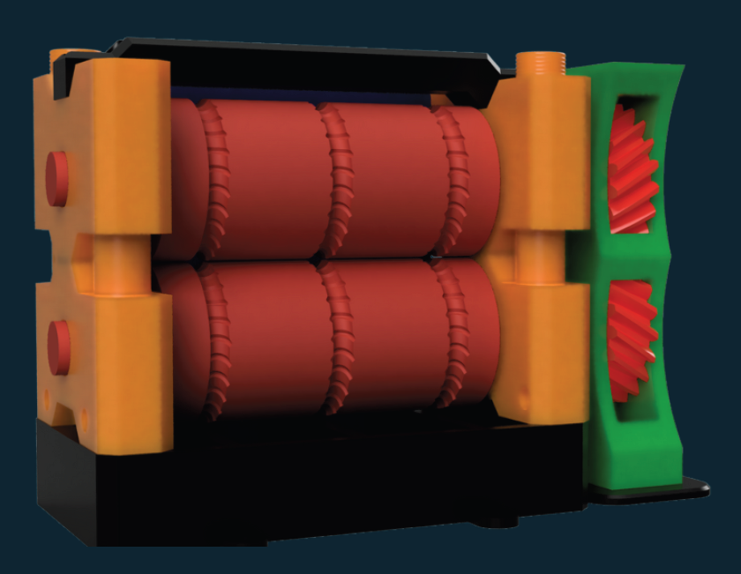
Figure 3. 3D CAD Design of potential mechanical sorbent recycling system using a “roller mill” design.
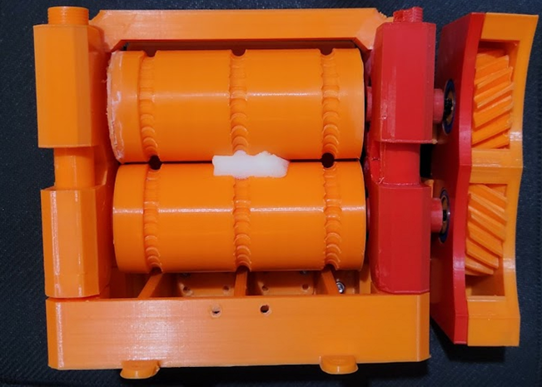
Figure 4. 3D Printed Model of a mechanical sorbent recycling system using a “roller mill technique” which is compatible with MTMS Aerogel as the sorbent.
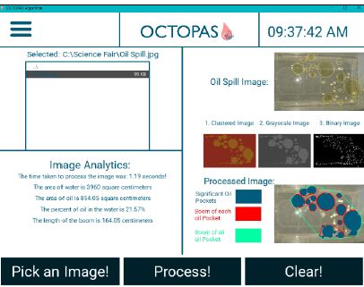
Figure 5. Design / Layout of OCTOPAS App.

[0006] DETAILED DESCRIPTION OF THE INVENTION
The present invention, OCTOPAS, is an integrated and automated system designed for the efficient and sustainable cleanup of oil spills in aquatic environments. It addresses the limitations of conventional methods by employing intelligent path planning, autonomous operation, and on-site recycling of sorbent materials.
I. System Architecture Overview
The OCTOPAS system generally comprises three main interacting sub-systems:
1. Image Acquisition and Processing Sub-System (OCTOPAS App): Responsible for spill detection, analysis, and strategic planning.
2. Autonomous Sorbent Deployment and Retrieval Unit (OCTOPAS Boat): The physical component that interacts with the spill, deploying and collecting sorbents.
3. On-Board Sorbent Recycling Sub-System: Located on the OCTOPAS Boat, enabling the reuse of sorbents and recovery of oil.
II. Image Acquisition and Processing Sub-System (OCTOPAS App)
a) Image Acquisition: Images of the oil spill are typically acquired using an unmanned aerial vehicle (drone) equipped with a suitable camera (e.g., visual, multispectral, or thermal). These images provide an overview of the spill's extent and characteristics.
b) Image Processing Algorithm (Figure 2): The OCTOPAS App (Figure 5) incorporates a novel image processing algorithm to analyze the captured images. This algorithm may include steps such as:
- Color Space Conversion: Converting the image to a color space more suitable for oil detection (e.g., HSV - Hue, Saturation, Value).
- Image Segmentation: Using techniques like K-means clustering to group pixels with similar characteristics, thereby distinguishing oil from water and other features.
- Thresholding: Converting the image to a binary format (e.g., using adaptive thresholding on a grayscale version) to clearly delineate oil-covered areas.
- Contour Detection and Analysis: Identifying the boundaries (contours) of individual oil patches.
- Morphological Operations: Applying operations like closing or opening to refine the detected oil patches, fill small gaps, or remove noise.
c) Path Optimization and Analytics: Based on the processed image, the App calculates:
- The total area of the oil spill and individual patches.
- An optimal path for the OCTOPAS Boat to traverse the spill, prioritizing containment (e.g., edges of the spill) and efficient coverage of oil patches.
- The estimated amount of sorbent required for specific patches.
- Real-time analytics such as percentage of oil cleaned, sorbent deployed, etc.
d) Communication: The OCTOPAS App communicates the generated path, deployment instructions, and other commands wirelessly (e.g., via Bluetooth, Wi-Fi, or radio frequency depending on the size and range of the oil spill) to the OCTOPAS Boat. It may also receive status updates from the boat. Updated drone images may also be taken to display the progress, and update the cleanup process.

III. Autonomous Sorbent Deployment and Retrieval Unit (OCTOPAS Boat)
a) Platform: The OCTOPAS Boat is an unmanned vehicle designed for stability and maneuverability in aquatic environments. It houses the necessary propulsion, power, navigation, and control systems.
b) Navigation and Control: The boat is equipped with GPS / other sensors for autonomous navigation & localization along the path provided by the OCTOPAS App. It can adjust its course and speed as required.
c) Sorbent Storage and Deployment: The boat contains a storage compartment for the sorbent material. A controlled deployment mechanism (e.g., a conveyor, auger, or pneumatic dispenser) releases the sorbent onto the oil slicks as per the App's instructions, potentially varying the deployment rate based on the thickness or area of the oil patch. The general path will be determined by the app, but can be dynamically changed based on sensor input from the boat, and an update in real time.
d) Sorbent Retrieval: After the sorbent has absorbed oil, the OCTOPAS Boat employs a retrieval mechanism (e.g., a mechanical scoop, a net system, or a conveyor belt intake) to collect the oil-laden sorbents from the water surface and transfer them to the on-board Sorbent Recycling Sub-System.

IV. On-Board Sorbent Recycling Sub-System
This sub-system is a key innovative component of OCTOPAS, enabling the efficient reuse of sorbents.
a) Input: Receives oil-saturated sorbent material collected by the retrieval mechanism.
b) Oil-Sorbent Separation: The core of the recycling sub-system is the separation process. For flexible sorbents like MTMS aerogel, this can be achieved through methods including, but not limited to:
- Mechanical Compression: Applying pressure to the sorbent to squeeze out the absorbed oil. The flexibility of MTMS aerogel makes it suitable for this. (Figure 3 & 4)
- Solvent Extraction (Optional): Using a suitable solvent to dissolve the oil from the sorbent, followed by solvent recovery.
- Thermal Desorption (Optional): Heating the sorbent to vaporize the oil, followed by condensation and collection of the oil.
- The preferred embodiment primarily utilizes mechanical compression due to its simplicity, energy efficiency, and suitability for flexible aerogels, potentially augmented by other methods if needed for specific oil types or sorbents.
c) Outputs:
- Cleaned Sorbent: The sorbent material, with a significant portion of the oil removed, is then returned to the sorbent storage compartment for immediate redeployment.
- Recovered Oil: The extracted oil is collected in a separate storage tank on the boat for later offloading and proper disposal or potential repurposing.
V. Sorbent Material
While the OCTOPAS system can potentially be adapted for various sorbents, it is optimized for use with reusable, high-efficiency materials. The preferred sorbent is a Methyltrimethoxysilane (MTMS) based hydrophobic silica aerogel. Key properties include:
- Superhydrophobicity: Repels water while selectively absorbing oil.
- High Sorption Capacity: Capable of absorbing many times its own weight in oil (e.g., >10 g/g, and cumulatively >100 g/g over multiple cycles).
- Flexibility and Robustness: Allows for mechanical compression during recycling without significant degradation over many cycles.
- Reusability: Can undergo numerous absorption-desorption cycles while retaining a high percentage of its initial absorption capacity.
VI. Method of Operation (Workflow Example)
- An oil spill occurs and is detected.
- A drone is launched to capture aerial imagery of the spill.
- Images are transmitted to the OCTOPAS App.
- The App processes the images, identifies oil slicks, calculates the optimal cleanup path, and estimates sorbent requirements.
- Instructions are sent wirelessly to one or more OCTOPAS Boats, pre-loaded with sorbent.
- The OCTOPAS Boat(s) autonomously navigate to the targeted areas.
- The boat(s) deploy sorbent material onto the oil.
- After a predetermined absorption time, or upon instruction, the boat(s) retrieve the oil-saturated sorbent.
- The retrieved sorbent is fed into the on-board Sorbent Recycling Sub-System.
- Oil is extracted from the sorbent via mechanical compression (or other means). The recovered oil is stored.
- The cleaned sorbent is made available for redeployment.
- The boat(s) continue the cycle of deployment, retrieval, and recycling until the spill is substantially cleaned or they require resupply/offloading.
- Live statistics (e.g., area cleaned, oil recovered) are transmitted back to a control station or the App.
As shown in figure 1.
VII. Potential Embodiments and Variations
- Multiple Boat Operation: For larger spills, a fleet of OCTOPAS Boats can be deployed, coordinated by the OCTOPAS App to work in tandem.
- Alternative Sorbents: The system can be adapted to use other types of recyclable sorbents, with potential modifications to the recycling sub-system.
- Scalability: The OCTOPAS Boat and its sub-systems can be scaled up (e.g., to lifeboat size for larger offshore spills) or down as needed.
- Enhanced Intelligence: Future embodiments may incorporate advanced AI/ML algorithms for more dynamic path planning, adaptive sorbent release based on real-time sensor feedback (e.g., oil thickness sensors), or predictive modeling of spill behavior.
- Modular Design: The Sorbent Recycling Sub-System could be designed as a modular unit that can be fitted to various oil cleanup platforms.
- Sorbent Reloading/Oil Offloading: Mechanisms for at-sea reloading of fresh/recycled sorbents (e.g., from a mother ship or drone delivery for lightweight sorbents) and offloading of recovered oil can be incorporated for extended operation.

